|  |  |
| --- | --- |
| Ex.No:3 | TIME TABLE |
| Date: |

AIM:

To Write a html webpage page to display your timetable.

# ALGORITHM:

### STEP 1: Create a simple table using table tag

### STEP 2: Add header row using the tag

### STEP 3: Add your timetable

### STEP 4: Execute the program

PROGRAM:

HTML:

<!DOCTYPE html>

<html lang="en">

<head>

<title>Slot Timetable</title>

</head>

<body>

<center>

<img src="SEC.png" height="100" width="540">

</center>

<br>

<table align="center" width="540" cellspacing="2" cellpadding="4" border="5" bgcolor="cyan">

<caption><b>SLOT TIME TABLE - SHAHIN J(212223040190)</b></caption>

<tr align="center">

<th bgcolor="yellow">Day/Time</th>

<th bgcolor="yellow">Monday</th>

<th bgcolor="yellow">Tuesday</th>

<th bgcolor="yellow">Wednesday</th>

<th bgcolor="yellow">Thursday</th>

<th bgcolor="yellow">Friday</th>

</tr>

<tr align="center">

<th bgcolor="yellow">8-10</th>

<td>MATHS</td>

<td>FREE SLOT</td>

<td>SOFT SKILLS</td>

<td>FWAD</td>

<td>DE</td>

</tr>

<tr align="center">

<th bgcolor="yellow">10-12</th>

<td>COMM ENGLISH</td>

<td> FREE SLOT </td>

<td>CA</td>

<td>MATHS</td>

<td>CA</td>

</tr>

<tr>

<th bgcolor="yellow">12-1</th>

<td colspan="5" align="center">L U N C H</td>

</tr>

<tr align="center">

<th bgcolor="yellow">1-3</th>

<td>FWAD</td>

<td>FWAD</td>

<td>DE</td>

<td>COMM ENGLISH</td>

<td>FREE SLOT</td>

</tr>

<tr align="center">

<th bgcolor="yellow">3-5</th>

<td colspan="5"> FREE SLOT </td>

</tr>

</br>

</table>

<br>

<table align="center" cellspacing="2" cellpadding="4" border="2">

<tr align="center">

<th>S. No.</th>

<th>Subject Code</th>

<th>Subject Name</th>

</tr>

<tr>

<td align="center">1.</td>

<td align="center">19AI414</td>

<td>FUNDAMENTALS OF WEB APPLICATION DEVELOPMENT (FWAD)</td>

</tr>

<tr>

<td align="center">2.</td>

<td align="center">19EY701</td>

<td>SOFT SKILLS</td>

</tr>

<tr>

<td align="center">3.</td>

<td align="center">19EE404</td>

<td>DIGITAL ELECTRONICS (DE)</td>

</tr>

<tr>

<td align="center">4.</td>

<td align="center">19CS305</td>

<td>COMPUTER ARCHITECTURE (CA)</td>

</tr>

<tr>

<td align="center">5.</td>

<td align="center">19MA201</td>

<td>CALCULUS AND MATRIX ALGEBRA (MATHS)</td>

</tr>

<tr>

<td align="center">6.</td>

<td align="center">19EN101</td>

<td>COMMUNICATIVE ENGLISH (COMM ENGLISH)</td>

</tr>

</br>

</table>

</body>

</html>

OUTPUT:

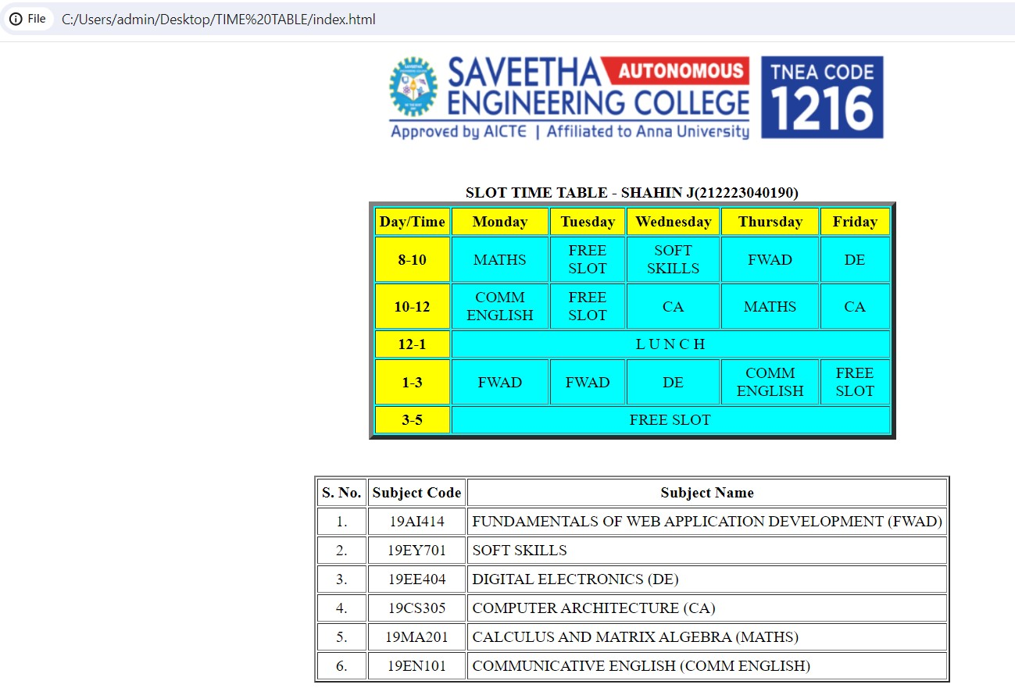

RESULT:

The program for creating slot time table is completed successfully.